CORTEXIUM: Context-Aware AI Driving Assistant & AR HUD System
Part 1: Comprehensive Project Analysis (IEEE Paper Ready)
1. What is the project/module about?
Cortexium is an edge-executable, real-time context-aware Advanced Driver Assistance System (ADAS) and Augmented Reality Heads-Up Display (AR-HUD). It processes forward-facing dashcam video and GPS telemetry to monitor driving behavior, detect environmental hazards, render 3D perspective AR navigation directly onto the road surface, and generate comprehensive post-trip safety coaching analytics.
2. What problem does it solve?
- Driver Distraction from Traditional 2D Turn-by-Turn Navigation: Conventional GPS screens force drivers to shift visual focus away from the road to interpret abstract 2D map lines.
- Delayed Collision & Tailgating Hazard Detection: Drivers frequently misjudge relative headway distance and lane boundary drift.
- Lack of Objective Driver Evaluation & Safety Feedback: Traditional vehicles provide no quantifiable, automated feedback on dangerous driving habits (e.g., tailgating, erratic steering, improper lane positioning).
3. What is the main objective?
To design a lightweight, unified vision-and-telemetry system that:
- Accurately tracks vehicles, road lanes, and driver context at 30+ FPS.
- Projects perspective-corrected 3D AR navigation cues on the road without obstructing the driver's forward view.
- Provides non-intrusive, priority-based auditory warnings and automated post-drive diagnostic safety reports.
4. What are the main features/functions?
- Real-Time Object & Vehicle Detection: Employs YOLOv8n to identify cars, buses, and trucks in the vehicle’s path with bounding-box tracking.
- Monocular Headway & Distance Estimation: Estimates relative distance to leading vehicles using bounding-box scaling and triggers collision/tailgating alerts.
- Lane Detection & Drift Analysis: Uses computer vision algorithms (Canny edge detection, Region of Interest masking, Hough Line Transform) to calculate lane center offset, deviation, and steering stability.
- Driver Context Verification: Analyzes interior cockpit characteristics to verify whether the system is actively in an operating vehicle before running pipeline logic.
- Dynamic 3D AR Projection & Glassmorphic HUD:
  - Computes vanishing-point ground perspective to render glowing neon-green chevrons strictly bounded to the road surface (Y_MAX_ROAD clipping mask).
  - Overlays a glassmorphic status HUD (Traffic, Speed Limit 40 sign, Safety status) and floating 3D destination signage.
  - Cognitive-Load Optimized Routing UI: Replaces traditional restrictive visual blocking (e.g., heavy red cross-outs over incorrect lanes) with non-intrusive, context-aware advisory text (e.g., indicating a path does not lead to the destination), ensuring the driver maintains full visual awareness of all physical road options.
- Turn-Aware Behavioral Rule Scoring: Evaluates lane stability and headway distance into a smoothed 0–100 safety score. Automatically suppresses false drift penalties during legitimate maneuvers/turns.
- Priority-Based Audio TTS Alert Engine: Multithreaded text-to-speech engine (pyttsx3) that schedules critical warnings (collision risk) above informational advisories with state cooldowns to prevent alarm fatigue.
- Post-Trip Telemetry Logging & PDF Report Generation: Generates multi-page PDF performance reports (fpdf2, matplotlib) with trend regression analysis, violation breakdowns, and coaching recommendations.
5. How does it work, step by step?
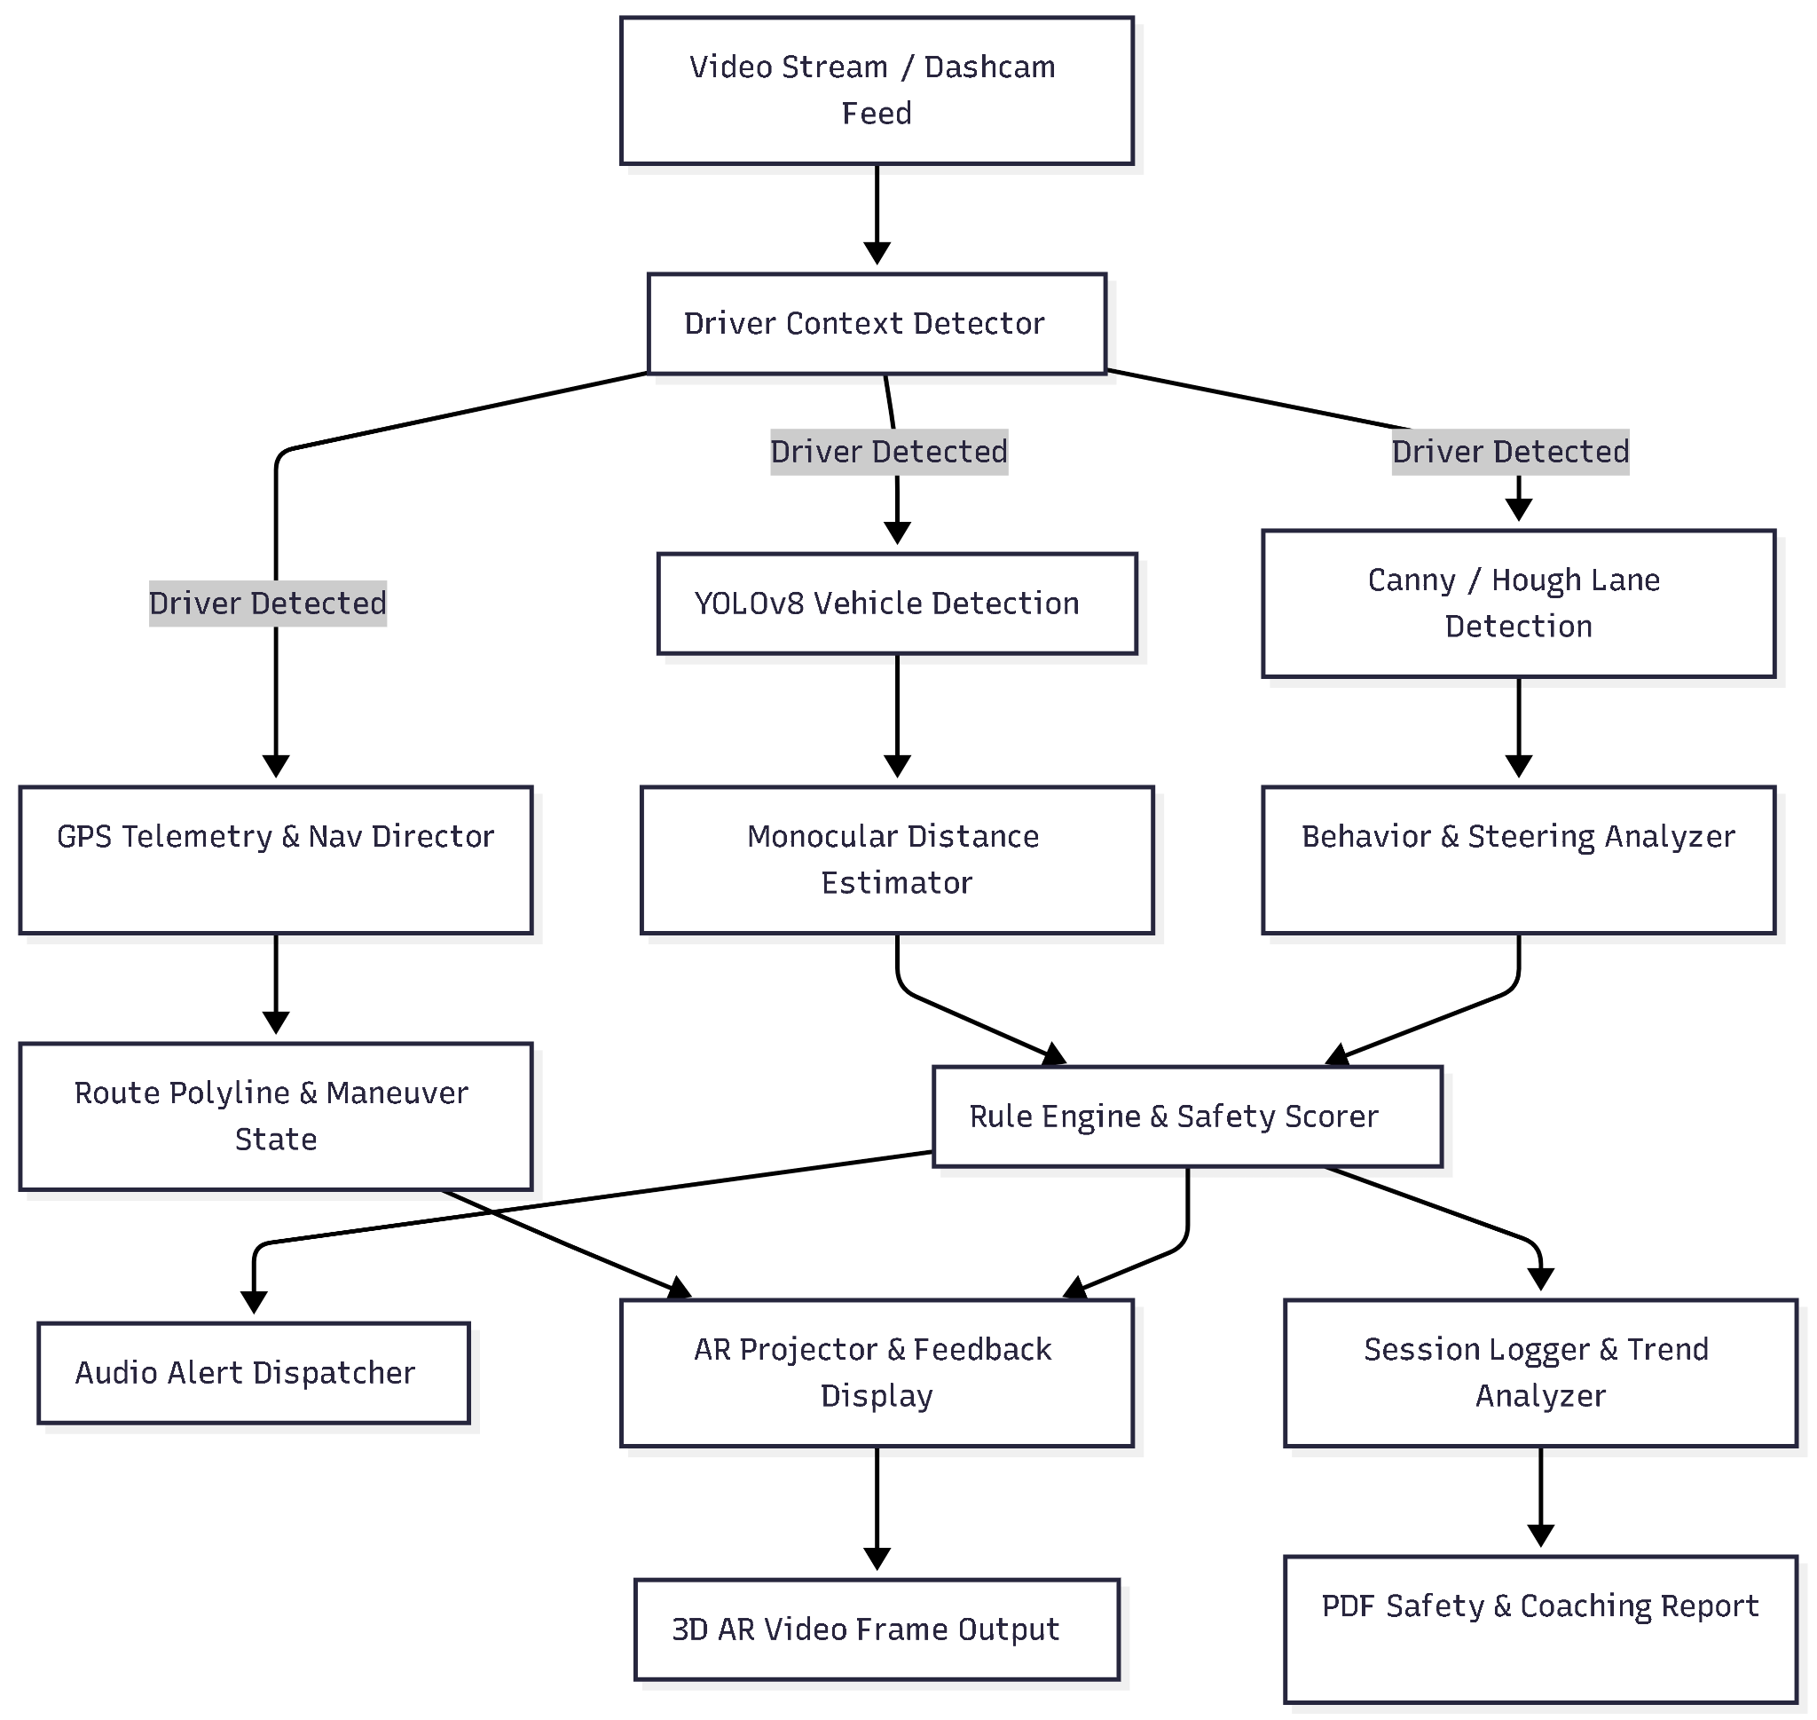
Frame Capture & Context Check: VideoInput captures the live camera/video frame. DriverContextDetector ensures the vehicle is in an active driving context.
- Parallel Perception:
  - VehicleDetector executes YOLOv8 inference to detect bounding boxes of surrounding vehicles.
  - LaneDetector segments left/right lane boundaries, computing lane center offset.
  - NavDirector & GoogleRouteEngine resolve current GPS coordinates against route nodes to identify upcoming maneuvers and distances.
- Behavioral Analysis & Scoring:
  - DistanceEstimator computes headway distance and flags collision risks.
  - BehaviorAnalyzer measures lateral drift and steering instability.
  - RuleEngine computes the frame safety score (0–100) and deduplicates deduction penalties during turns.
- AR Projection & Audio Output:
  - ARProjector renders perspective-projected ground chevrons with Y_MAX_ROAD hood-masking, floating destination signboards, speedometer, and the top-right status card.
  - AudioAlertManager asynchronously queues and speaks priority alerts.
- Session Aggregation & Reporting:
  - Frame metrics are recorded by SessionLogger.
  - Upon session termination, TrendAnalyzer and ReportGenerator compile safety charts, violation breakdowns, and coaching insights into an exportable PDF.
6. What technologies/tools are used?
- Computer Vision & Deep Learning: OpenCV (cv2), Ultralytics YOLOv8 (yolov8n.pt), EasyOCR (easyocr).
- Numerical & Data Processing: NumPy (numpy), Pandas (pandas).
- Routing & Geo-Spatial: Google Maps Directions API, Polyline encoder/decoder (polyline), Requests (requests).
- Audio / Speech: Microsoft SAPI / TTS engine via pyttsx3.
- Data Visualization & Document Generation: Matplotlib (matplotlib), FPDF2 (fpdf2).
- Language & Runtime: Python 3.10+, PowerShell / Bash CLI.
7. Who would use it and what are the main use cases?
- Commercial Fleets & Logistics: Fleet managers monitoring driver safety compliance, tailgating habits, and generating automated risk reports.
- Consumer ADAS & Smart Cockpits: Retrofitted smart dashcam or heads-up display hardware for everyday drivers seeking augmented navigation and collision alerts.
- Automotive Telematics & Insurance (UBI): Usage-Based Insurance providers calculating dynamic actuarial risk scores from empirical driving behavior.
8. What are the inputs and outputs?
- Inputs:
  - Forward dashcam RGB video stream (camera feed or MP4 file).
  - GPS telemetry data (data/telemetry.csv containing latitude, longitude, speed, heading).
  - Destination selector input (Downtown, Airport, Mall).
  - Google Maps API Key (.env).
- Outputs:
  - Real-time 3D AR composite video frame displayed at 30 FPS.
  - Real-time spoken auditory warnings (TTS).
  - Live console telemetry diagnostics.
  - Multi-page PDF driving diagnostic & coaching report (session_report_<timestamp>.pdf).
9. What is the main benefit or contribution of this module?
- Integrated Edge ADAS Pipeline: Unifies object tracking, lane boundary analysis, route navigation, and driver behavior evaluation in a single synchronous processing loop.
- Perspective-Corrected Masked AR: Solves the common AR UI clutter problem by mathematically grounding chevrons to road perspective vanishing points and masking them against the physical vehicle hood.
- Context-Aware Rule Filtering: Prevents false-positive lane deviation penalties during legitimate turn/curve maneuvers.
10. What are its main limitations?
- Monocular Depth Approximation: Headway distance is geometrically approximated from 2D bounding-box dimensions rather than LiDAR or stereo camera disparity.
- Lane Detection Environmental Sensitivity: Classical edge and Hough transform methods perform best on clearly marked asphalt and may degrade under heavy occlusion, severe glare, or unmarked dirt roads.
- API Dependency: Full turn-by-turn dynamic rerouting requires active Google Maps Directions API billing (though local telemetry fallback is implemented).
Part 2: Project Description Summary
1. Executive Summary
Cortexium is an intelligent, context-aware driving assistant software system designed to bridge real-time edge computer vision with Augmented Reality Heads-Up Displays (AR-HUD). By synthesizing YOLOv8-based vehicle detection, classical lane-boundary tracking, monocular collision risk estimation, and GPS-synchronized navigation, Cortexium creates an immersive, non-obtrusive driving experience. It delivers real-time spatial navigational cues, priority voice warnings, and generates automated, analytical post-drive safety audits.
2. Core Capabilities
- Perception & Ranging: Real-time multi-class vehicle detection with monocular headway distance estimation and collision alerting.
- Lane Dynamics & Behavior Scoring: Lateral deviation measurement, steering instability analysis, and dynamic 0–100 safety index evaluation.
- World-Space AR Projection: 3D road-plane perspective chevrons with neon-glow shading and strict vehicle hood boundary clipping (Y_MAX_ROAD).
- Screen-Space Glassmorphic HUD: Slim top status bar (Traffic, Speed Limit 40 sign, Safety rating), next-maneuver bar, and speedometer.
- Smart Audio Alert Dispatcher: Cooldown-managed, priority-queued text-to-speech audio feedback.
- Diagnostic Reporting Engine: Automated PDF report generation with regression curves, violation statistics, and actionable driver coaching insights.
3. System Architecture

4. Technology Stack
Layer | Technologies / Libraries
Language & Environment | Python 3.10+, PowerShell / Bash
Object Detection & Perception | Ultralytics YOLOv8 (yolov8n.pt), OpenCV (cv2)
OCR & Geometry | EasyOCR, NumPy, Polyline
Routing & APIs | Google Maps Directions API, Requests, Python-Dotenv
Telemetry & Data | Pandas, Smoother Utilities
Audio Engine | Pyttsx3 (SAPI5 Native Engine)
Reporting & Visualization | FPDF2, Matplotlib
5. Key Files & Structure
cortexium/
├── config.py # Global paths and system configurations
├── main.py # Main application lifecycle & execution loop
├── requirements.txt # Core project dependencies
├── .env # API credentials (Google Maps API Key)
│
├── core/ # Core functional modules
│ ├── ar_projector.py # 3D perspective AR chevrons & HUD drawing engine
│ ├── audio_alerts.py # Threaded priority TTS speech manager
│ ├── behavior_analyzer.py # Lateral lane offset & stability analyzer
│ ├── distance_estimator.py # Monocular distance & collision risk estimator
│ ├── driver_context.py # In-cabin driver presence validator
│ ├── feedback_display.py # Legacy / full-frame diagnostic HUD components
│ ├── GoogleRouteEngine.py # Google Maps API directions client & route polyline
│ ├── lane_detector.py # Canny edge & Hough transform lane detector
│ ├── nav_director.py # GPS coordinate-to-maneuver state director
│ ├── report_generator.py # Automated PDF driving safety report builder
│ ├── rule_engine.py # Safety scoring rules & maneuver penalty overrides
│ ├── session_logger.py # Frame-by-frame telemetry and metrics recorder
│ ├── session_summary.py # Terminal session aggregator
│ ├── trend_analyzer.py # Multi-session safety regression analysis
│ ├── vehicle_detector.py # YOLOv8 vehicle inference wrapper
│ └── video_input.py # Video capture and stream interface
│
├── data/ # Datasets, route telemetry & sample video files
│ ├── telemetry.csv # OCR-extracted latitude, longitude, speed & heading
│ └── sample_videos/ # Dashcam video recordings for offline testing
│
├── tools/ # Utility scripts
│ └── extract_telemetry.py # EasyOCR pipeline for extracting GPS from dashcams
│
└── utils/ # Mathematical & smoothing helper utilities
└── smoothing.py # Exponential moving average score smoother


